**EXPERIMENT NO: 10**

**CODE:**

#include<stdio.h>

#include<conio.h>

void main()

{

FILE *finput, *fmdt, *fmnt,*fpala,*fcala;

char t1[20],t2[20],t3[20];

int count=0;

finput=fopen("input.txt","r");

fmdt=fopen("mdt.txt","w");

fmnt=fopen("mnt.txt","w");

fpala=fopen("pala.txt","w");

fcala=fopen("cala.txt","w");

fscanf(finput,"%s%s%s",t1,t2,t3);

while(count!=2)

{

//if(strcmp(t1,"Mend")

if(strcmp(t1,"Macro")==0)

{

fprintf(fmdt,"\t%s\t%s\n",t2,t3);

fprintf(fmnt,"%s\n",t2);

fprintf(fpala,"%s\n",t3);

fscanf(finput,"%s%s%s",t1,t2,t3);

//fprintf(fpala,"%s\n",t3);

//count++;

//fprintf(fmdt,"Count = %d",count);

}

else if(strcmp(t1,"Mend")==0)

{

count++;

fprintf(fmdt,"%s\n",t1);

strcpy(t1,t2);

strcpy(t2,t3);

fscanf(finput,"%s",t3);

}

else

{

fprintf(fmdt,"%s\t%s\t%s\n",t1,t2,t3);

fscanf(finput,"%s%s%s",t1,t2,t3);

}

}

//fprintf(fmdt,"%s\n",t1);

fprintf(fcala,"%s\n",t2);

fscanf(finput,"%s",t1);

fprintf(fcala,"%s\n",t1);

fclose(finput);

fclose(fmnt);

fclose(fmdt);

fclose(fpala);

fclose(fcala);

//fprintf(fmdt,"%s\t%s\t%s",t1,t2,t3);

}

**INPUT:**

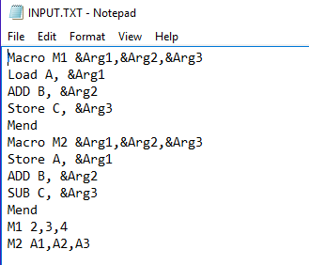

**OUTPUT:**

Macro definition table (MDT):

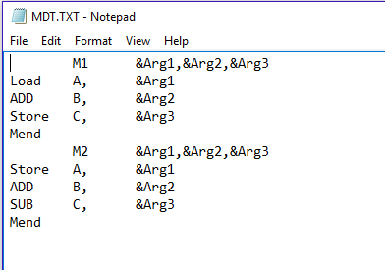

Macro name table (MNT):



Previous ALA:

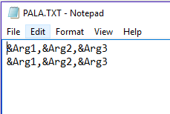

Current ALA:

